Assignment 7 - Docker with Microservices using Spring Boot - I

Docker is a self-contained unit of software that can be delivered on any server having its own isolated process and has its own file system. We would want to further explore Docker before we choose it for the deployment of our microservices. Basically, we would like to check the feasibility of the deployment and ease of use to make an informed decision. So perform the below-mentioned tasks and share your findings.

1. Install Docker on a linux based machine (preferable Ubuntu-20).

2. Check Docker version

3. Launch Docker Hello World example

4. List docker images

Hint: Use a Linux machine for installing Docker.

Solution

Task 1 :

The Docker was installed in Ubuntu machine, but there is an access issue due to which the screenshots were couldnt be captured. So alternatively, taking the screenshot from Windows machine

Task 2 :

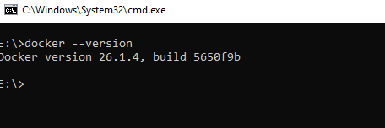

Task 3 :

### Pull the hello-world image

Now pull the hello-world image from docker use the below command:

docker pull hello-world

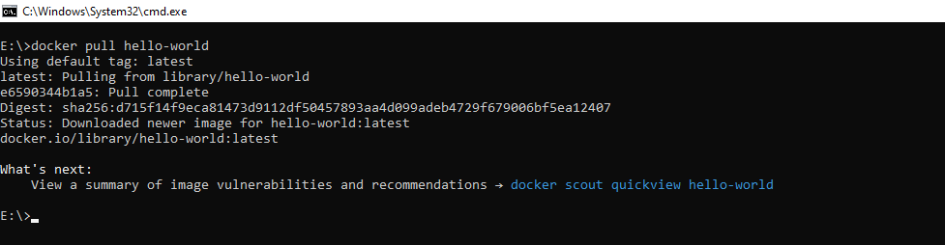

Command - **docker run hello-world**

Task 4 :

Command - **docker images**

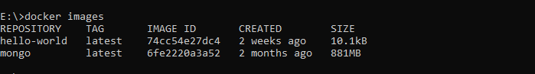

### Execute Hello world:

Use the below command to run the hello-world file in docker:

docker run hello-world

